VERBAL TO VISUAL

**Project Report**

**Project X**

at

Community of Coders, Veermata Jijabai Technological Institute July 2024

ACKNOWLEDGEMENT

Firstly, we would like to thank our mentors, **Rohan Parab** and **Param Parekh** for their commendable role as our mentors throughout this project. Their timely guidance, expertise in the domain and insightful feedback were crucial in shaping our project.

We are also grateful to VJTI’s COC for continuing the tradition of their seniors and providing this golden opportunity that made our project possible.

Yadnyesh Patil

[yadnyeshpatil@gmail.com](mailto:yadnyeshpatil@gmail.com)

Janvi Soni

[janvisoni273@gmail.com](mailto:janvisoni273@gmail.com)

Mudit Jain

<mailto:Muditjainofficial.001@gmail.com>

TABLE OF CONTENTS

| Sr. No | Title | Pg No. |
| --- | --- | --- |
|  | Overview |  |
|  | Deep Learning and Neural Networks  2.1 Introduction  2.2 Algorithms  2.3 Activation Functions  2.4 Tuning Process |  |
|  | Natural Language Processing  3.1 Tokenization  3.2 Text Embeddings  3.3 Image Embeddings |  |
| 4. | Text to Image Methods  4.1 Modern Hopfield Networks  4.2 GANs  4.2.1 DCGANs  4.2.2 StackGANs  4..2.3 XLNet |  |
| 5. | Results |  |
| 6. | Problems Faced |  |
| 7. | Future Prospects |  |
| 8. | References |  |

OVERVIEW

When people listen to or read a narrative, they quickly create pictures in their mind to visualize the content. Many cognitive functions, such as memorization, reasoning ability, and thinking, rely on visual mental imaging or “seeing with the mind’s eye” . Developing a technology that recognizes the connection between vision and words and can produce pictures that represent the meaning of written descriptions is a big step toward user intellectual ability.

The term text-to-image (T2I) is the generation of visually realistic pictures from text inputs. In T2I generation, the model takes an input in the form of a human written description and produces a RGB image that matches the description using GANs which are capable of generating realistic-images based on prompts.

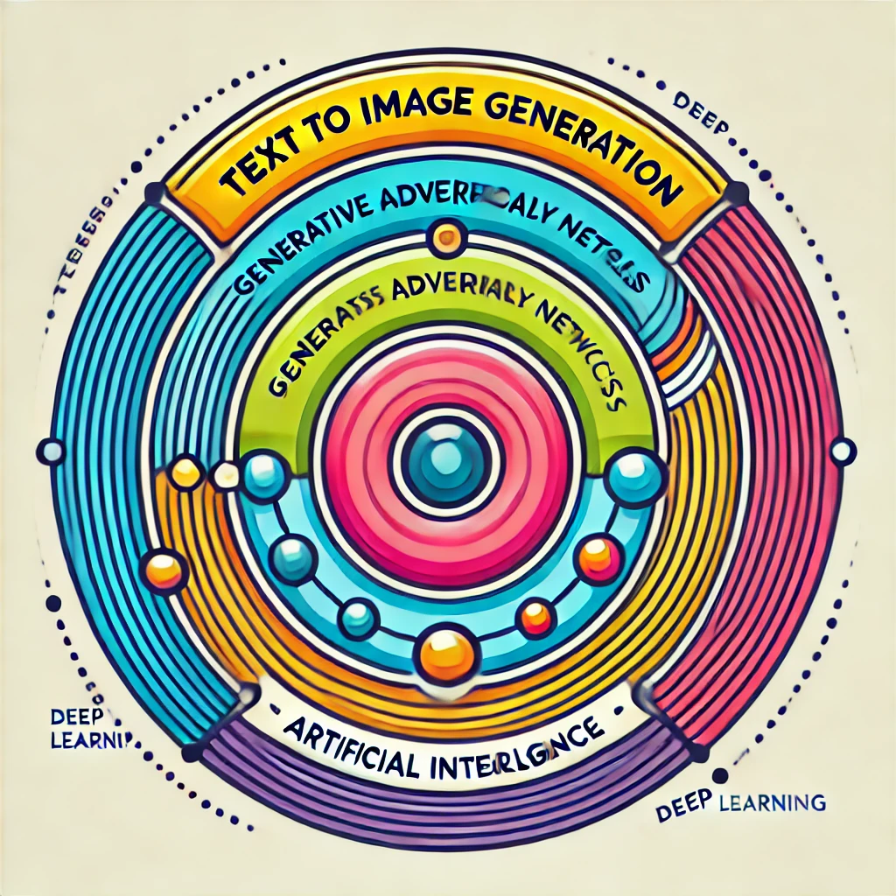

**Deep Learning and Neural Networks**

Neural Networks are a subset of machine learning models inspired by the structure and functioning of the human brain. These consist of processing units called ‘neurons’ which are basically activation functions which when connected to other nodes can process the data and extract large amounts of features. In the training process weights are adjusted based on the difference between the predicted output and original output.

Deep Learning consists of many layers(signifying the word ‘deep’) which excel in hierarchical representations of data, making them suitable for complex tasks. CNNs and RNNs come under Deep Learning architecture which serve as important tools for image and text feature extraction respectively. The number of hidden layers increases significantly, allowing the model to learn the patterns.

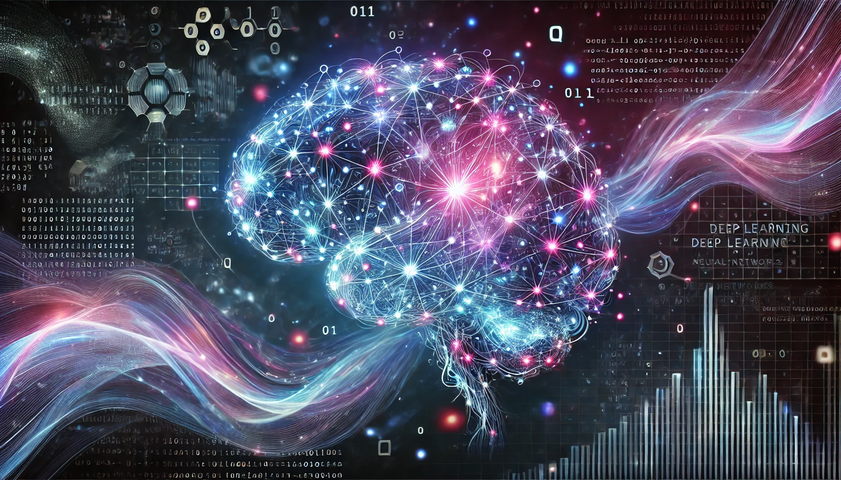

Algorithms

1. *Logistic Regression* : Logistic Regression is used for binary classification problems, where the goal is to classify data into one of two categories (like "yes" or "no," "spam" or "not spam").

Logistic Regression starts by creating a linear equation that takes input features (like words in an email, age, income) and combines them into a single number (called the log-odds).

The linear combination (log-odds) is passed through the sigmoid function to turn it into a probability (a number between 0 and 1), and based on this probability a prediction is made.

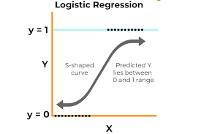

1. *k-Nearest Neighbors (k-NN)* : k-Nearest Neighbors (k-NN) is used for both classification and regression tasks. The idea behind k-NN is to classify a new data point based on the majority class of its nearest neighbors.

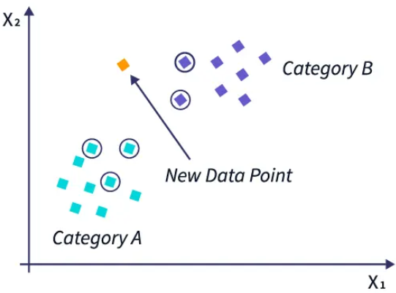

Activation Functions

Activation functions basically bring non-linearity to the networks so that the network can be useful to perform complex tasks.

1. *sigmoid* : The sigmoid function squashes the input values between 0 and 1, making it useful for models where we need to predict probabilities.

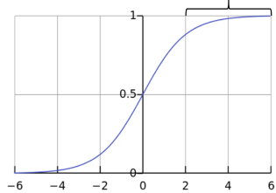

1. *Tanh* : It ranges the output between -1 and 1 having zero-centered output which makes it easier for models to learn effectively .

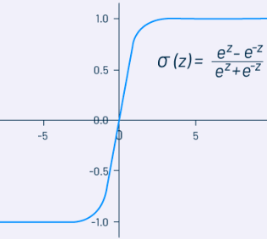

1. *ReLU* : The rectified linear activation function is simpler than the sigmoid. If x is less than or equal to 0, then y is 0 — otherwise, y is equal to x.

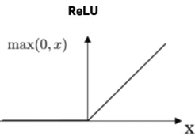

1. *Leaky ReLU* : A variant of ReLU, the Leaky ReLU allows a small negative slope (usually 0.01) when the input is negative instead of outputting zero, where the problem of Dying ReLU is fixed.
2. *Linear function* : A linear function is simply the equation of a line. It will appear as a straight line when graphed, where f(x)=x and the output value equals the input.

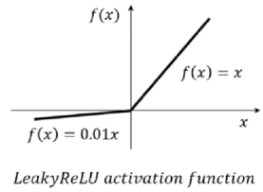 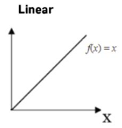

Tuning Process

The tuning process is the optimization of model parameters and hyperparameters to improve model performance.

1. Regularization : Regularization is used to prevent overfitting, which occurs when a model learns noise and details in the training data rather than the underlying distribution. This consists of various methods like :

a] *L1 Regularization (Lasso Regression)* : It adds a penalty term to the loss function to prevent overfitting. By penalizing large coefficients, L1 regularization encourages simpler models that generalize better to new data.

b] *Dropout* : A random subset of neurons is chosen to be "dropped out”. By preventing neurons from co-adapting too strongly, dropout helps improve the model's ability to generalize to unseen data.

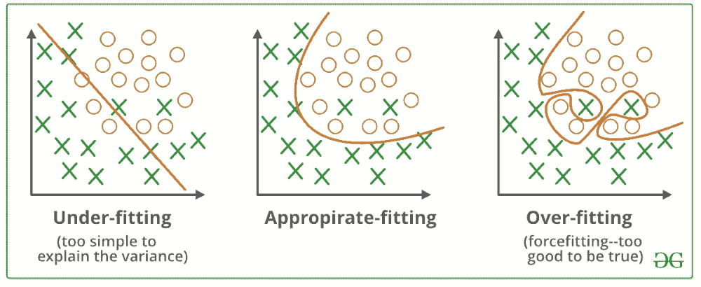

Natural Language Processing

Natural Language Processing (NLP) is a branch of AI that enables computers to understand, interpret, and generate human language in a meaningful way. It helps machines process and analyze large amounts of natural language data, like text or speech, so they can perform tasks such as language translation, sentiment analysis, text summarization, and even answering questions. NLP combines computational linguistics (rules and structure of language) with machine learning to understand the context, meaning, and nuances in language. It's used in things like virtual assistants, search engines, and voice recognition systems.

1. *Tokenization* : Tokenization is a fundamental step in Natural Language Processing (NLP) that involves splitting text into smaller units, called "tokens," which can be words, subwords, or characters. Tokenization prepares text for further processing (like removing stop words), allowing NLP models to analyze and understand the structure and meaning of the text. Some tokenization methods are WhiteSpace and Punctuation based tokenization, Byte-Pair Encoding(BPE), Rule-based tokenization and character tokenization, etc.

We have implemented BPE in our model for the tokenization of the captions of the images.

a] BPE- Byte-Pair Encoding (BPE) is a technique that starts by representing words as individual characters and then iteratively merges the most frequent pairs of characters or subwords to form larger units. It continues this process until a certain number of merges (or subwords) is reached, creating a vocabulary of subwords.

b] Why is BPE useful?

1. *Handles Rare Words*: Instead of treating every word as a single unit (which may not always appear in training data), BPE breaks rare words into smaller, more common subwords. For example, the word "unhappiness" might not appear frequently, but BPE can break it into smaller, meaningful parts like "un," "happi," and "ness."
2. *Smaller Vocabulary*: BPE reduces the size of the vocabulary compared to word-based tokenization, as common subwords (like prefixes and suffixes) are reused across different words.
3. B*etter for Morphologically Rich Languages*: In languages with many word forms (e.g., Turkish, Finnish), BPE can capture the relationships between different word forms by breaking words into smaller subwords.

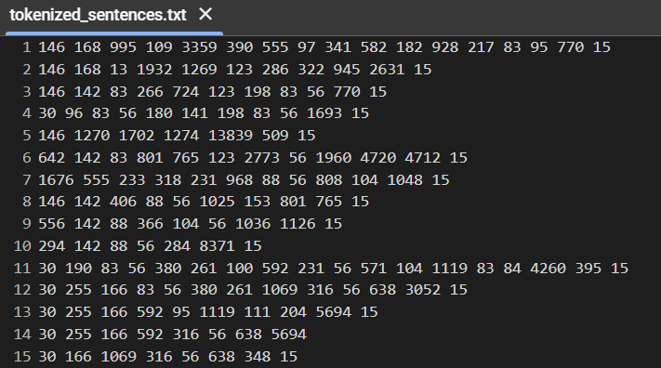

2) *Text Embeddings* : Text embeddings are numerical representations of text data, such as words, sentences, or even entire documents, in a way that captures their semantic meaning and relationships. These embeddings enable machine learning models to work with text efficiently because they transform text into continuous vectors in a high-dimensional space, allowing algorithms to compare, analyze, and learn from the meaning behind the text.

Why Use Text Embeddings?

The main reason to use text embeddings is that raw text cannot be processed directly by machine learning models, as models require numerical inputs. Traditional methods, like one-hot encoding, often fall short because they don't capture relationships between words. For example, one-hot vectors for "cat" and "dog" would be completely different, even though the words are semantically related. Text embeddings solve this by representing words or sentences in a way that similar texts have similar vector representations. We have utilized BERT

Model for the text embeddings.

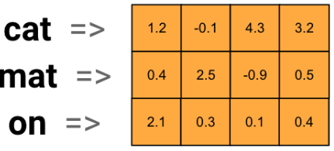

3) *Image Embeddings* : Image embeddings are numerical representations of images that capture their visual features in a way that machine learning models can process and analyze. Like text embeddings, image embeddings map images into a high-dimensional vector space, where similar images are represented by vectors that are close to each other, allowing for various tasks such as image classification, retrieval, and recognition.

Why Use Image Embeddings?

Image embeddings allow models to understand and process images in a more efficient way than using raw pixel values. They reduce the dimensionality of image data while preserving important features like shapes, textures, colors, and spatial relationships between objects in the image. This helps us for performing tasks like Image Classification, Image Retrieval, Object Detection and Image Generation, etc.

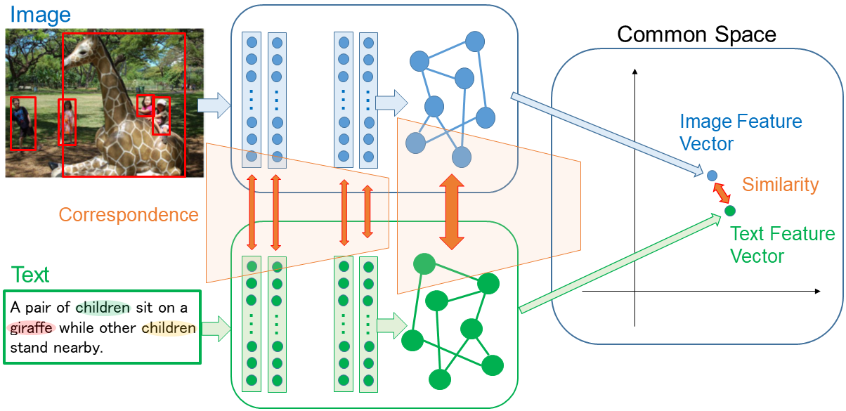

Text to Image Methods

1. *Modern Hopfield Networks* : MHNs can provide unique advantages by allowing for the storage and retrieval of high-dimensional patterns, which can be applied to tasks such as generating images from textual descriptions.

* Various Aspects under MHN :

a] Memory and Retrieval Capacity - MHNs enhance the memory storage capacity of traditional Hopfield networks. In text-to-image tasks, they can store large numbers of high-dimensional embeddings, such as image embeddings or token embeddings from text. This allows the model to associate complex textual descriptions with corresponding image patterns, improving the quality of image generation.

b] Associative Retrieval - MHNs leverage associative memory to retrieve stored patterns based on partial or noisy inputs. In text-to-image tasks, given a textual prompt, the network can retrieve associated image embeddings from memory, enabling the generation of coherent images even if the text is ambiguous or incomplete.

c] Connection to Attention Mechanisms - MHNs have a strong connection to attention mechanisms, specifically the self-attention mechanism used in transformers. In text-to-image systems, attention plays a crucial role in mapping different parts of the text (like nouns or adjectives) to their corresponding visual components in the image. MHNs can potentially improve attention by creating more stable memory representations of the text-image relationships.

* Workflow of MHN architecture:

a] Convert the input text into text embeddings and the input image into image embeddings.

b] Then we map the corresponding text embedding to image embedding forming a single {Text+Image} embedding.

c] This combined embedding will be passed to the Prototype learning blocks where there are Hopfield layers and Self-Attention Layers.

d] Then using softmax and auto regression we will output the predicted image tokens.

e] These image tokens will be passed to a decoder which will generate an image based on the input text.

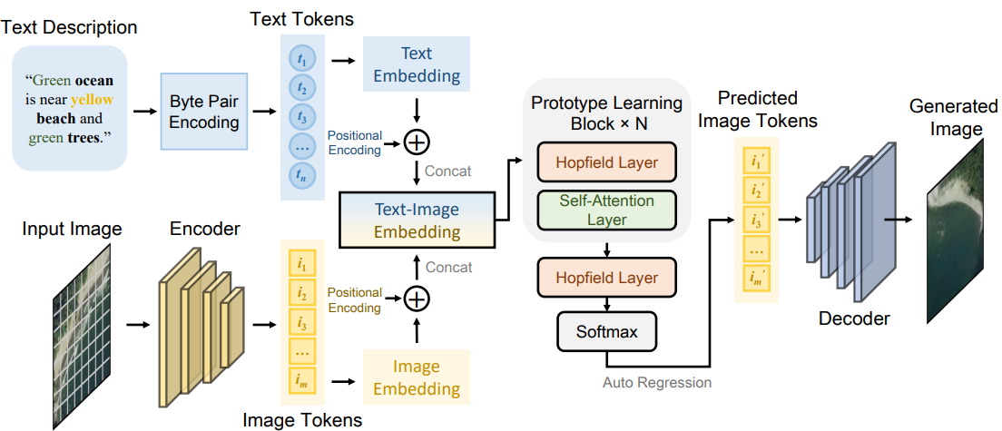

The basic Architecture of Modern Hopfield Networks can be observed in the above image.

1. *Generative Adversarial Networks(GANs)* : GANs are a class of deep learning models designed to generate new, synthetic data that mimics real data. They are widely known for their ability to create realistic images, but can also be used for generating other types of data such as music, video, and even text.

A GAN consists of two neural networks that compete with each other in a game-like scenario :

1. Generator - This network generates new data instances (e.g., images).
2. Discriminator - This network evaluates whether a given instance of data is real (from the training dataset) or fake (generated by the generator).

The generator’s goal is to produce data that is indistinguishable from real data, while the discriminator’s goal is to correctly distinguish between real and generated data. Over time, the generator learns to produce increasingly realistic data.

How GANs Work?

a] The generator starts with random input, often called "noise," which is sampled from a random distribution (like a Gaussian distribution). Input to the GAN is {random noise + text embeddings}

b] Now the generator takes this random vector as input and tries to generate a fake data sample (such as an image). Initially, these samples will be very noisy, as the generator has no knowledge of the real data.

c] Now the discriminator takes an input (a real sample from the training data and the fake sample from the generator) and outputs a probability that the input is real or fake. It is essentially a binary classifier.

d] Now both networks are trained simultaneously in a process called adversarial training:

1. The discriminator tries to correctly classify inputs as real or fake.
2. The generator tries to fool the discriminator by generating realistic data that the discriminator cannot classify as fake.

e] GANs are framed as a minimax game. The generator tries to minimize the probability that the discriminator can distinguish between real and fake data, while the discriminator tries to maximize that probability.

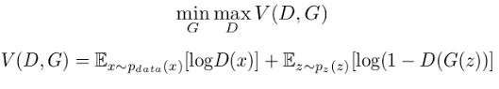

GAN Architecture :

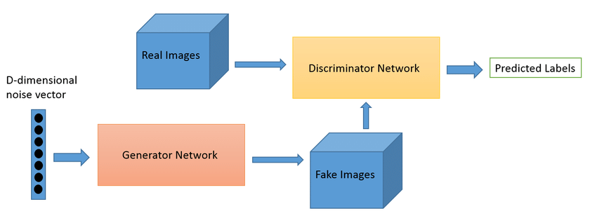

1. DC GANs - In a standard GAN, the generator and discriminator are usually composed of fully connected (dense) layers. However, for tasks like image generation, convolutional neural networks (CNNs) are more effective due to their ability to capture spatial hierarchies and features in images. A DCGAN incorporates convolutional layers in place of fully connected layers in both the generator and discriminator.

* Key Features :

1. In DCGANs, the generator uses transposed convolutional layers to upsample from a low-dimensional latent space (typically a random noise vector) to generate high-resolution images.
2. The discriminator uses regular convolutional layers to downsample the input images and classify them as real or fake.
3. In the discriminator, the LeakyReLU activation function is commonly used instead of the standard ReLU, which helps the network learn better by allowing small negative gradients, thus preventing "dead" neurons.
4. The tanh activation function is used in the output layer of the generator to normalize the generated images to a range between -1 and 1.

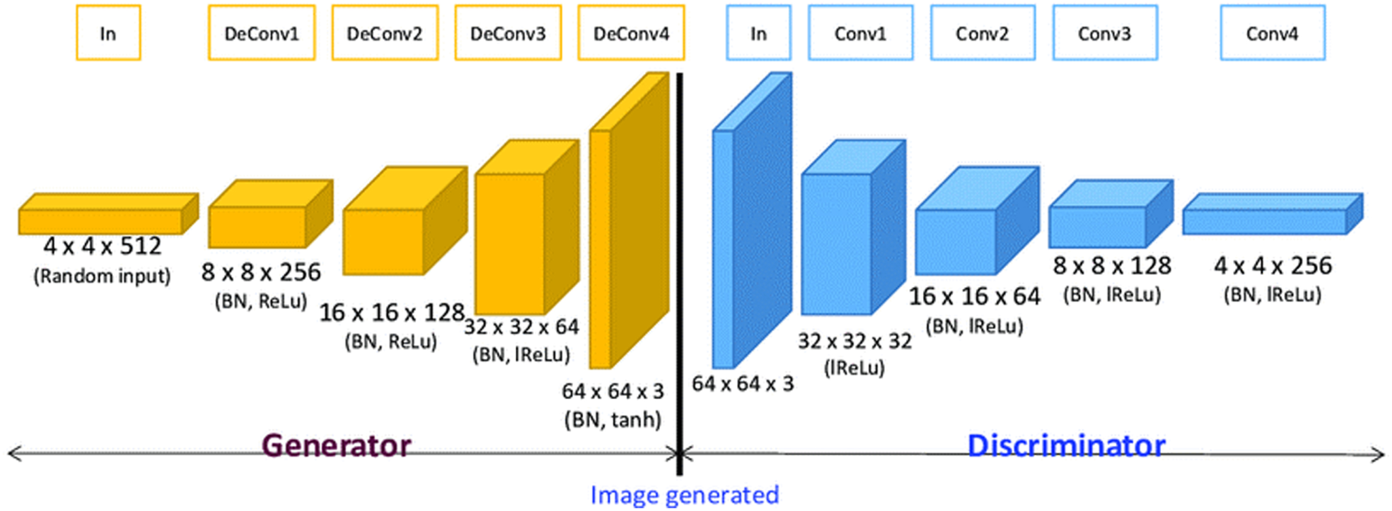

2. Stack GANs - StackGANs aim to produce high-quality images that align closely with specific textual descriptions. The architecture consists of two stages, each handled by a different GAN, which helps in progressively refining the generated images.

* Key Features :

1. The architecture here consists of 2 stages : Stage-I(Coarse Generation) and Stage - II(Fine Generation).
2. Stage-I : This stage takes a textual description and generates a low-resolution image (e.g., 64x64 pixels) that captures the basic structure and overall features described in the text.
3. Stage-II : The low-resolution image generated by Stage I, along with the original textual description, serves as input for this stage. This stage refines the image by adding more details and enhancing its quality.

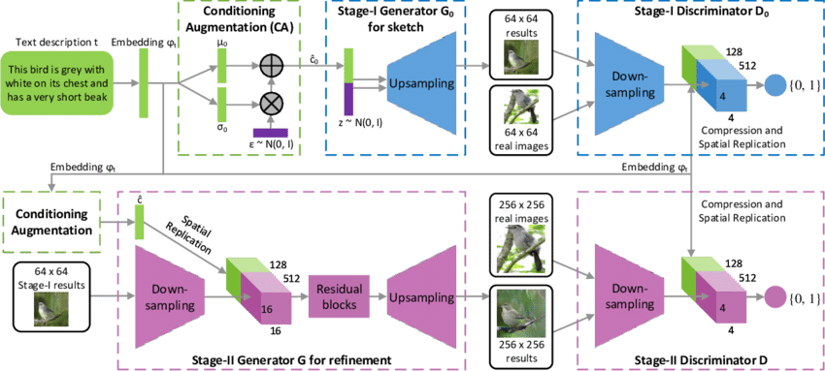

Stack GANs basically give an opportunity to improve the quality of the image by increasing its resolution in the process of training itself.

3. XLNet : XLNet is a text encoder which captures rich contextual embeddings from text descriptions, allowing the classification model to understand the nuances and relationships between different flower types based on their descriptions. [In the context of our Project].

XLNet generates rich contextual embeddings from text inputs by capturing dependencies between words in a sentence. This allows the model to understand the semantics of textual descriptions thoroughly, which is crucial for tasks that require detailed understanding, such as generating corresponding images from text.

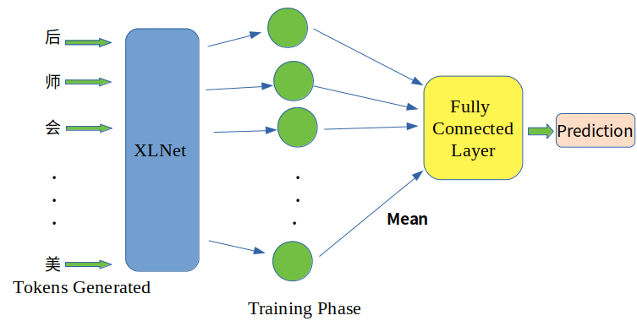

Making the use of XLNet and GANs, we were able to generate the images of flowers based on prompts.

* Where XLNet was used to generate the text embeddings from the captions present in the dataset.
* GANs generated the image based on the text embeddings they were fed.

The combination of GANs + XLNet proves to be effective because the system can simultaneously learn from textual and visual data, enhancing its ability to generate images that are contextually aligned with the input text.

The discriminator in GANs provides feedback to the generator, allowing it to refine the generated images iteratively. When the generator uses high-quality text embeddings from XLNet as input, this feedback loop becomes more effective, leading to better convergence and higher-quality outputs.

XLNet outperformed BERT, because even using the BERT model we were not able to get an image which corresponds to the prompt.

Results

| Input (Prompt) | Output (Image) |
| --- | --- |
| 1. The flower has petals that are pink and has a green stamen |  |
| 1. The flower is white and purple in color, and has petals that are wavy and ruffled |  |
| 1. An orange flower with yellow stigma |  |
| 1. The flower has petals that are yellow with green pedicel |  |

Problems Faced

1. The Major problem we faced was that the difference between the Generator and Discriminator losses was too high, we tried changing the learning rate but it didn't make any difference.
2. Then later we came to know that the Cross-Entropy function was not effective in the process then we turned to Wasserstein Loss.
3. Mode collapse : It occurs when the generator produces a limited diversity of outputs, often generating the same or very similar samples repeatedly instead of exploring the entire data distribution.

Wasserstein Loss also helped in preventing the mode collapse.

1. The loss became stagnant indicating that either generator or discriminator had no scope of improving.
2. Very high generator loss indicates that the generator is having a difficult time producing outputs that are convincing enough to fool the discriminator.
3. Model took approximately 8 hours to train and lack of computation power was a major issue.
4. Lack of datasets having relevant captions to the images.
5. Local GPUs were not able to process the images quickly.

Future Scope

1. Firstly, we will train the model on more datasets having relevant captions and a large number of images.
2. We will try to implement the Stage-II of Stack GANs and convert the 64x64 images into 256x256 images increasing the clarity of the output.
3. We will also try to implement the MHN in which we will train the image+text embedding mapping.
4. Then we can also deploy the model and make a User-Interface so that the users can perform text-to-image tasks.